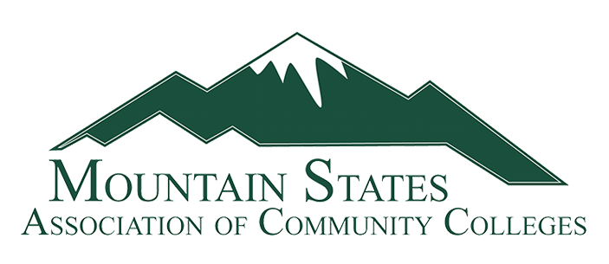

Registration

The Mountain States Association of Community Colleges Annual Conference will be held at the High Country Motor Lodge, in Flagstaff, AZ, July 10 – 12, 2025.

Please complete the registration form and return it to Candy Laney at Miles Community College, [laneyc@milescc.edu](mailto:laneyc@milescc.edu) **no later than April 15, 2025**.

|  |  |  |  |
| --- | --- | --- | --- |
| First Name |  | Last Name |  |
| College |  | | |
| Address |  | | |
| Email |  | Phone # |  |

|  |  |  |  |  |  |
| --- | --- | --- | --- | --- | --- |
|  | Yes |  | No | I will be bringing a guest to the MSACC Summer Conference | |
| Spouse/Guest Name | | | | |  |

|  |  |
| --- | --- |
| Any food allergies or restrictions |  |

**Thursday, July 10, 2025**

|  |  |  |  |  |
| --- | --- | --- | --- | --- |
|  | Yes |  | No | I will attend the Welcome Reception with dinner following. |
|  | Yes |  | No | My spouse/guest will be attending with me. |

**Friday, July 11, 2025**

|  |  |  |  |  |
| --- | --- | --- | --- | --- |
|  | Yes |  | No | I will attend conference sessions, including lunch. |
|  | Yes |  | No | I will attend conference sessions, but will not be attending lunch. |
|  | Yes |  | No | I will be attending the group dinner. |
|  | Yes |  | No | My spouse/guest will attend the dinner with me. |

**Saturday, July 12, 2025**

|  |  |  |  |  |
| --- | --- | --- | --- | --- |
|  | Yes |  | No | I will attend conference sessions and would like a box lunch. |
|  | Yes |  | No | I will attend conference sessions and do not want a box lunch. |

**Hotel reservations:**

**Candy Laney will be taking hotel reservations for the conference. Please complete the information below.**

|  |  |  |  |  |  |
| --- | --- | --- | --- | --- | --- |
| **Date of Arrival** | **Date of Departure** | **Last Name** | **First Name** | **Cell Phone Number** | **Number of Guests** |
|  |  |  |  |  |  |

The Association will pay for rooms on July 10 and 11. Members who may want to arrive early or stay longer will be responsible for those extra days. If you would like to stay additional days prior to July 10 or after July 12, please identify this above. Extra nights are dependent upon room availability at the hotel. The hotel will try to accommodate all requests but rooms will not be held for dates outside the conference dates. If you are looking at staying prior to or after the conference dates, contact me with those dates as soon as possible.

**Transportation:**

There is no hotel shuttle to and from the Flagstaff Pulliam Airport. Here is a link to the transportation options from the airport. <https://flyflagstaffaz.com/travelers/ground-transportation/>

**Please call Candy Laney if you have questions, at 406-874-6165.**